**Project Proposal**

Matthew Ferrett

University of Lincoln, School of Computer Science

[18681724@students.lincoln.ac.uk](mailto:18681724@students.lincoln.ac.uk)

Word Count: 1408

**Abstract:** The “project name” offers a system that allows the use and automation of photography. “NAME” is aimed to help people with mental health, genetic or neurological conditions take self-portraits in a comfortable environment. The aim of the project is to implement a system where anyone can have a self-portrait taken without the stress of a new or unfamiliar third-party being involved. I have established the needs, risks, and hurdles for this project by thoroughly researching the current market and research understanding, and I have implemented a step-by-step plan on how to complete this project and demonstrate competence and ingenuity.

**Keywords:** Face-detection, smile recognition, Social Anxiety Disorder, social phobia, Autism Spectrum Disorder, deep learning

1. Introduction

Mental health is a massive and relevant issue in the modern day, however, people with mental health issues aren’t the only people who may struggle to have a self-portrait taken. People with certain genetic or neurological disorders such as autism spectrum disorder, down-syndrome, or Alzheimer’s to name a few, could also find a situation in-front of a camera or a photographer very stressful or foreign. The aim and rationale for this project is therefore incredibly straight forward, the reduction of emotional stress or friction in said situations by means of avoiding the problem overall. And to also provide a means of access to those of whom may usually struggle to have a picture taken due to restlessness or lack of understanding/ ability to follow instructions.

With all of this in-mind and after studious research into the subject area I propose this document as a literature review and plan for how it can be used to reduce any social and emotional friction one may endure whilst having a self-portrait taken, and to ensure as many people as possible have the chance to get their picture taken. The literature review will discuss the existing and established theory and research in face-detection, smile recognition and the impact social phobias, genetic or neurological conditions can have on having a portrait taken. The project proposal in full will describe any aims and objectives I have during the project. It will also include a plan on how I will complete the project including the steps it will take to get there and any methods for collection of information and data. I will outline any project specific risks and include a plan on how I will mitigate them.

Undeniably people with the above-mentioned predispositions would benefit from the applied system immensely; a reduction in the situational social and emotional friction would ensure the process went smoothly, and the mentioned party could have a positive experience overall. The benefit of a system in this use-case would be the inclusion of those of whom may struggle to sit still or understand the key aspects to a photography session. Thus, the system’s beneficiaries will be the photographed subject, and their peers who get to enjoy a picture of their loved ones. I believe there is a market for photography of those most marginalised in society.

This project is key to computer science and computer vision as it harnesses the well-studied and researched technology - facial detection and smile recognition. The latter literature review will cover the research and means for pursuing this use-case and topic of study.

1. Aims and Objectives

The aim of this project is to create a system that can be used to accommodate those in society who may struggle with getting their photo taken. Following an egalitarianists approach to photography, everyone should have equal representation when it comes to getting their picture taken.

To ensure I meet my aim I have broken it down into five SMART objectives. The objectives must meet the criterium of being, specific, measurable, achievable, relevant and time limited. They are as follows:

* The main objective is to create a system that is inclusionary to those in society who struggle to get a picture taken, it helps reduce emotional or situational friction when the user is having a photograph taken, and it helps those who may struggle to understand the concept of photography.
* To ensure the objective is measurable it will be important that the project is used and tested, I will use public datasets to do so.
* I can implement pre-made libraries such as OpenCV for python, (Home - OpenCV, 2021), using pre-made libraries will streamline the design and implementation process, it’ll reduce the number of risks that could interfere with the project. In terms of algorithms there is a large body of research in convolutional neural networks, the advantages are large. Here’s a paper discussing multi-layer back propagation to learn large collections of data. (LeCun and Bengio, 2021)
* It would be unethical to test users with said issues prior to the project implementation, therefore the measurability will be tested through later analysis of use.
* I will use a mixture of primary and secondary data during research and testing, initially I will use secondary data from large pre-made datasets to train and test the algorithms, but I will later use my own primary data to test the efficacy of the final product.
* The objective is most certainly achievable as face and smile detection algorithms already have a large body of research.
* The objective is realistic and practical due to the large body of research into the mentioned topics.

The challenging part of the project will be fully incorporating a system that tracks face movement, has adequate smile detection, and can be used on a wide variety of cameras.

1. Academic Literature

Face detection and smile recognition is an extensive area of study and research, and years of effort and cooperation has been used to vastly improve the technology, “*there has been extensive studies done in the domain of Face Detection in the past, and various robust algorithms have been proposed and evaluated on different datasets.* (Shahzad, Qasim and Fraz, 2021.)” However, through my own research I struggled to find systems specifically oriented towards reducing emotional stress and friction through photography sessions for those of whom struggle to interact with new people. With my own research into mental health, genetic and neurological conditions, I believe It should be noted that any system designed to reduce any notable implications should be researched and incorporated into one’s emotional friction reducing plan. *“Research suggests that, among individuals with ASD without intellectual disability, higher cognitive ability is associated with more awareness and social comparison, which may result in more awareness of impairments in social performance and therefore lead to more anxiety and depression.* (Zukerman, Yahav and Ben-Itzchak, 2021)” And with lifetime anxiety on the rise, (Unlocking Potential, 2021,) These studies can point my project in the direction where it is needed most, the chosen target audience will benefit greatly from reduced stress and emotional friction in their day to day lives. (Zukerman, Yahav and Ben-Itzchak, 2021.) A quote that motivates me in this project relating to the reduction of friction is from a book called ‘Atomic Habits’ by James Clear, it says, “*when we remove the points of friction that sap our time and energy, we can achieve more with less effort.* (Clear, 2018).” To me this means a lot, I believe that for those who struggle the most with self-consciousness, social-anxiety or other social issues, the reduction of friction can make a huge difference overall, one small reduction of friction could make the difference to one’s day in a large way.

1. Project plan and Risk Analysis
   1. Plan and Gantt Chart

My data will be both descriptive and quantitative as the data being used is simply labelled images, the algorithms are to be trained on pre-labelled images, and the final testing will be a measurement of success. I will only be interested in the outcome of the code, e.g., if the code ran, identified the user, and took the picture appropriately. I am using quantitative data collection as I believe it is useful for systematically labelling the large datasets that I will use.

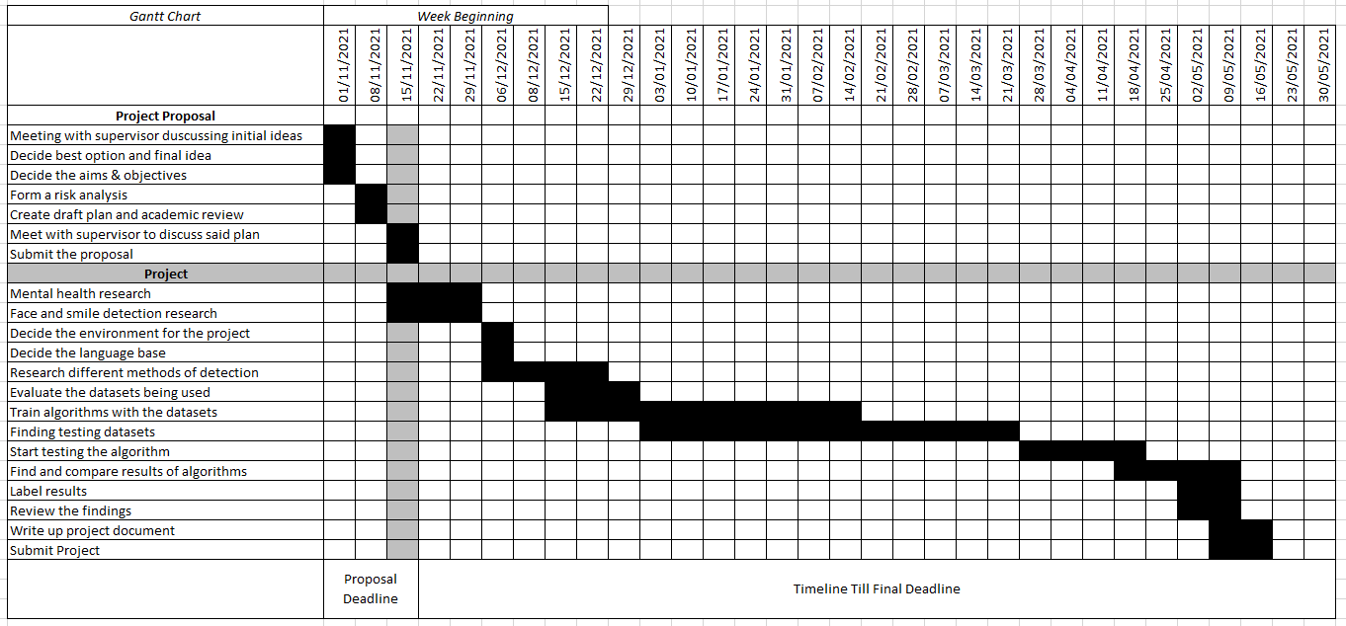

**Fig 1.** A Gantt chart showing the timeline for my project, including deadlines

* 1. Risk Analysis

|  |  |  |  |  |
| --- | --- | --- | --- | --- |
| Risk Number | Specific Risk | Likelihood | Assessed Impact | Mitigation |
| 1 | Open-source programs become closed | Medium | Medium | Use a variety of open-source programs  Create custom training algorithm |
| 2 | Poor quality data sets | Medium | High | Use a wide variety of different datasets |
| 3 | Datasets become closed source | Low | Medium | Use a wide variety of different datasets |
| 4 | High computational resource requirements | Medium | Medium | Use a high-performance system  Or use compressed data |

References

Shahzad, M., Qasim, H. and Fraz, M., 2021. Deep Learning for Face Detection: Recent Advancements. 2021 International Conference on Digital Futures and Transformative Technologies (ICoDT2). p.1.

Clear, J., 2018. Atomic Habits. [S.l.]: Random House.

OpenCV. 2021. Home - OpenCV. [online] Available at: <https://opencv.org/> [Accessed 17 November 2021].

LeCun, Y. and Bengio, Y., 2021. Convolutional Networks for Images Speech and Time Series. [online] Iro.umontreal.ca. Available at: <http://www.iro.umontreal.ca/~lisa/pointeurs/handbook-convo.pdf> [Accessed 17 November 2021].

Zukerman, G., Yahav, G. and Ben-Itzchak, E., 2021. The Gap Between Cognition and Adaptive Behavior in Students with Autism Spectrum Disorder: Implications for Social Anxiety and the Moderating Effect of Autism Traits. [online] Link-springer-com.proxy.library.lincoln.ac.uk. Available at: <https://link-springer-com.proxy.library.lincoln.ac.uk/article/10.1007/s10803-020-04632-y#Abs1> [Accessed 17 November 2021].